DBMS LAB 6

NAME: SACHIN HANSDA
ROLL NO.: 111601019

A.University database

1. Create a table hostel with attributes (name, location). Insert values (‘alpha’,’NE’),
(‘beta’,’SE’),(‘gamma’,’NW’),(‘delta’,’SW’). Create a table student_hostel
(student_id, hostel_name, room_number). student_id refers to id in student table,
hostel_name refers to name in hostel table. room _number is alpha-numeric type.
Possible values are A1 to A47, B1 to B47. Write a trigger so that, whenever a
new student is added to student table the student gets a room allocated. Rooms
are allocated in sequence: hostel names as given before and room numbers as
given above.
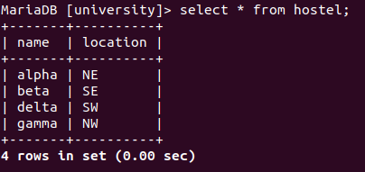

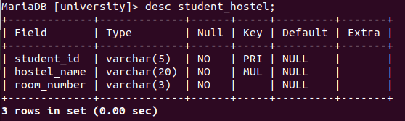

Trigger Code(SQL):

DROP TRIGGER IF EXISTS allocate_room;
DELIMITER $$
CREATE TRIGGER allocate_room
AFTER INSERT ON student FOR EACH ROW
BEGIN
declare hn varchar(30);
declare rn varchar(20);
declare alpha_count int;
declare beta_count int;
declare delta_count int;
declare gamma_count int;
select count(*) into alpha_count from student_hostel where hostel_name = 'alpha';
select count(*) into beta_count from student_hostel where hostel_name = 'beta';
select count(*) into delta_count from student_hostel where hostel_name = 'delta';
select count(*) into gamma_count from student_hostel where hostel_name = 'gamma';

if alpha_count < 94 then
set hn = 'alpha';
if alpha_count < 47 then
set rn = concat('A', alpha_count + 1);
else
set rn = concat('B', alpha_count - 47 + 1);
end if;
elseif beta_count < 94 then
set hn = 'beta';
if beta_count < 47 then
set rn = concat('A', beta_count + 1);
else
set rn = concat('B', beta_count - 47 + 1);
end if;
elseif delta_count < 94 then
set hn = 'delta';
if delta_count < 47 then
set rn = concat('A', delta_count + 1);
else
set rn = concat('B', delta_count - 47 + 1);
end if;
elseif gamma_count < 94 then
set hn = 'gamma';
if gamma_count < 47 then
set rn = concat('A', gamma_count + 1);
else
set rn = concat('B', gamma_count - 47 + 1);
end if;
else
SIGNAL SQLSTATE '45000'
SET MESSAGE_TEXT = 'HOSTELS ARE FULL';
end if;
insert into student_hostel values(NEW.ID,hn,rn);
END$$
DELIMITER ;

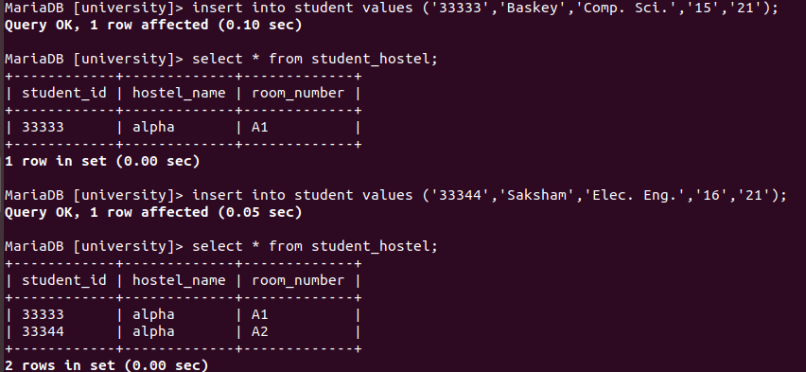

2. Create a table inst_dept by joining two existing table instructor and department.
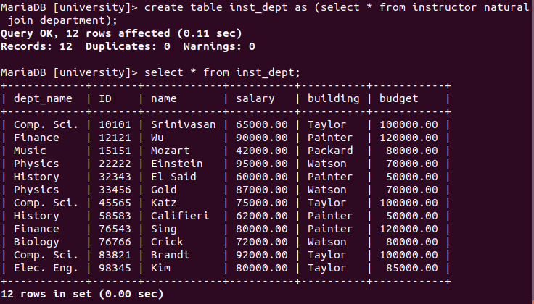

3. Write a trigger for stopping any update anomalies on budget and building in your
database.
a. User can update budget and/or building of any individual tuple in
inst_dept table or department table. Any update on budget or building in
any tuple in any table should automatically reflects on budget or building
of corresponding department for all redundant occurrence of it (even in
other tables).

Trigger Code (SQL):

DELIMITER $$
create trigger anomaly1
after update on department
for each row
begin
update inst_dept
set budget=new.budget
where dept_name=new.dept_name;
update department
set building=NEW.building
where dept_name=NEW.dept_name;
end;$$
DELIMITER ;

DELIMITER $$
create trigger anomaly2
after update on inst_dept
for each row
begin
update department
set budget=NEW.budget
where dept_name=NEW.dept_name;
update department
set building=NEW.building
where dept_name=NEW.dept_name;
end;$$
DELIMITER ;

b. Validate your trigger by executing following DML
i.
Update budget to ‘1,50,000’ of instructor whose name is
“Srinivasan” in inst_dept table.
ii.
Update budget and building of “Physics” department to ‘1,00,000’
and ‘Amstrong
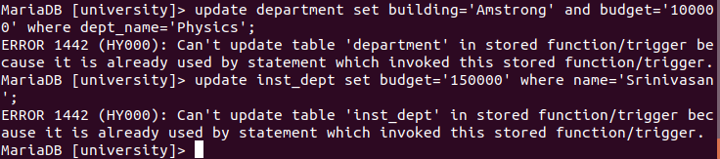

B. Canteen database

1. Create a database canteen . Create a table menu with attributes id int not null , and name
varchar(50) not null, type that can take value between healthy’ , and ‘unhealthy’ . Create
another table customerorder with attribute id not null , and count int not null . Create a
table price that will contain id of a dish in the menu and amount float

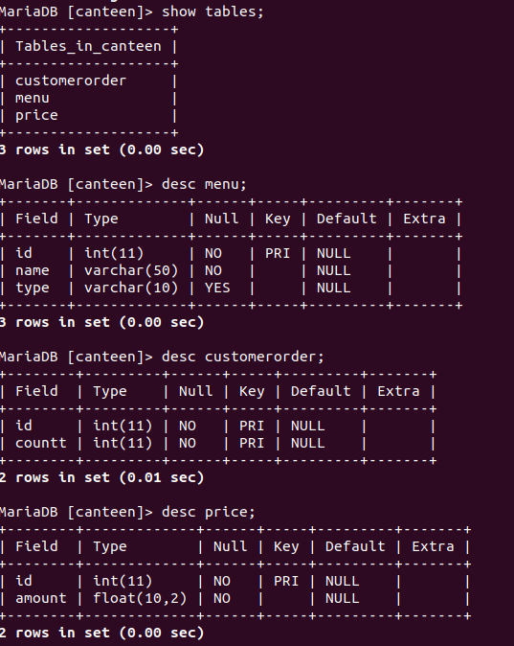
2. Create a trigger init that will initiate the count to zero for each entry in the menu table.
Insert one record to menu table, and show how init works.

Trigger Code(SQL):

create trigger init
after insert
on
menu
for each row
insert into customerorder(id,countt)
values(new.id,'0');

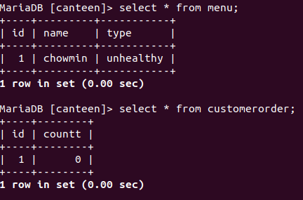

3. Drop the trigger init and show the effect.
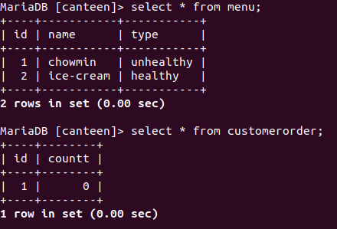

4. Create a trigger init_price that will check the type of the dish in the menu, and will
automatically initialize a price in the correct table. For healthy food price is 10, and for
unhealthy foods price is 15.

Trigger Code (SQL):

DELIMITER $$
create trigger init_price
after insert on menu for each row
begin
declare prc int;
if new.type = 'healthy' then
set prc = 10;
elseif new.type = 'unhealthy' then
set prc = 15;
end if;
insert into price values (new.id,prc);
end;$$
DELIMITER ;

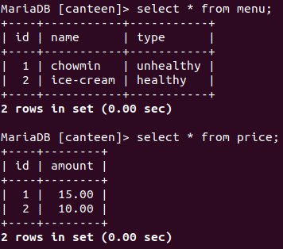

5. Create trigger price_checker that will raise error, and display message ‘price can not be
negative’ if accidentally someone tries to enter a negative price for some dish.

Trigger Code (SQL):

DELIMITER $$
create trigger price_checker
after insert on price for each row
begin
if new.amount < 0 then
signal sqlstate '45000'
set message_text = 'price can not be negative';
end if;
end;$$
DELIMITER ;

6. Modify the table menu to add an attribute spicy which can take value either ‘Y’ or ‘ N’ .
Create the attribute spicy as varchar but write a trigger s picy_checker to check the
validity. If invalid then raise an error and throw a message: ‘wrong spicy level!’.

Trigger Code (SQL):

DELIMITER $$
create trigger spicy_checker
after insert on menu for each row
begin
if new.spicy!='Y' and new.spicy!='N' then
signal sqlstate '45000'
set message_text = 'wrong spicy level';
end if;
end;$$
DELIMITER ;

